Contents
Topic: CSS Basics 3
Hands-On Exercises 3
Hands-On Exercise 1: CSS –Environment Setup 3
Hands-On Exercise 2: Basic Styling 3
Hands-On Exercise 3: Box Model 4
Hands-On Exercise 4: Advanced CSS 5
Hands-On Exercise 5 CSS Image 7

Topic: CSS Basics

Hands-On Exercises
Hands-On Exercise 1: CSS –Environment Setup
Estimated Completion Time: xx Minutes
(xx Marks)
Objective: After completing this exercise, you will execute understanding of Environment Setup and styling an element
- Including External CSS Files and using <style> tag
Complete the following assignment:
- Develop a HTML page ‘CSSEnvSetUp.html’. Which will have
  - A square with Red Background.
  - Rectangle with Blue Background.
- Try having the Styles inside a <style> tag and also trying applying styles through external CSS File. (Refer the element using id, class, tag name.).

To Submit: CSSEnvSetUp.html’

Hands-On Exercise 2: Basic Styling
Estimated Completion Time: xx Minutes
(xx Marks)
Objective: After completing this exercise, you will execute understanding styling an element for:
- Background
- Text
- Fonts
- Links
- Lists
- Tables

Complete the following assignment:

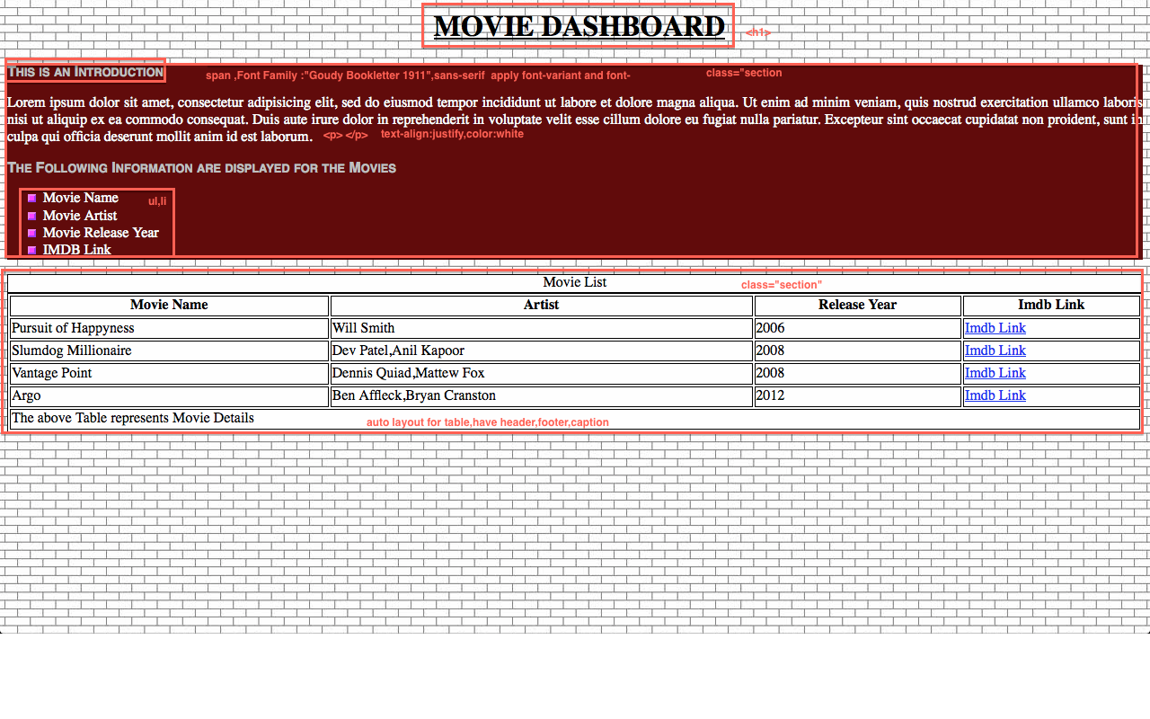
Create a HTML file with the following sections:
- Create a HTML File “CSSBasics.html”
- Use ‘images.jpg’ as background image and repeat it across the page.
- Observe the Screen shot and follow the hints given in the Red Color Font to achieve the objectives

To Submit: CSSBasics.html
Hands-On Exercise 3: Box Model
Estimated Completion Time: xx Minutes
(xx Marks)
Objective: After completing this exercise, you will execute understanding box model by applying padding, margin, and border for the elements

Complete the following assignment:

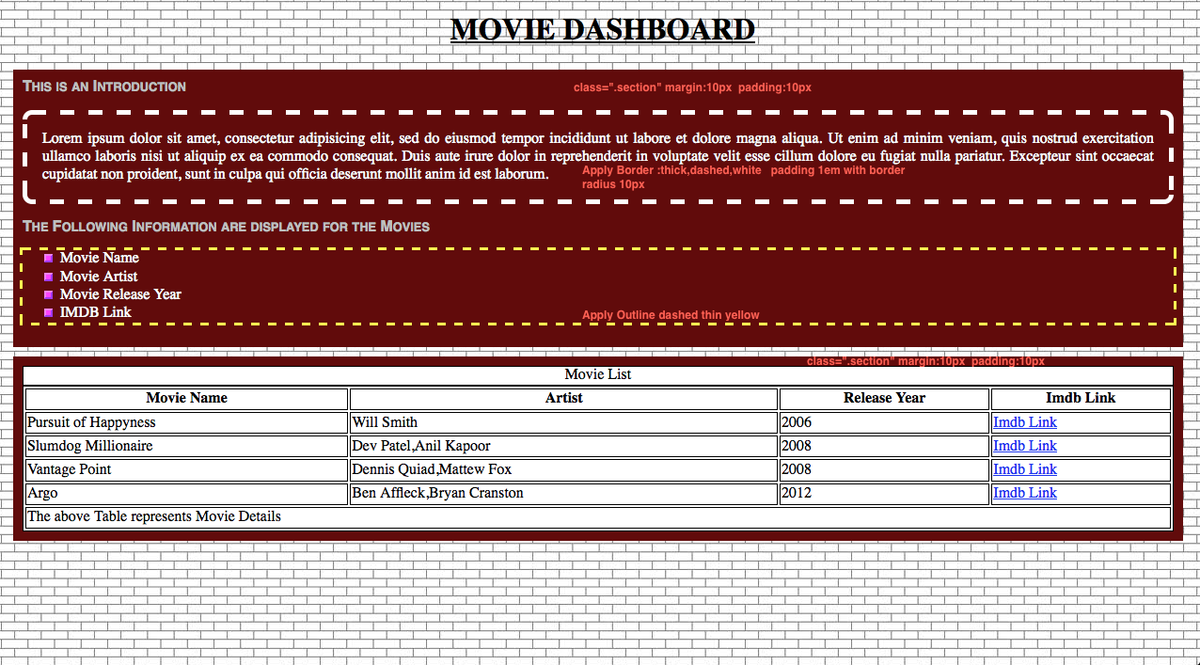
Create a HTML file with the following sections:
- Copy the Content of the “CssBasics.html” into a new HTML File “CSSBoxModel.html”

To Submit: CSSBoxModel.html

Hands-On Exercise 4: Advanced CSS
Estimated Completion Time: xx Minutes
(xx Marks)
Objective: After completing this exercise, you will execute understanding concepts like Grouping, Nesting, Dimension, Offset, Positioning, Floating, Clear ,Align.

Complete the following assignment:

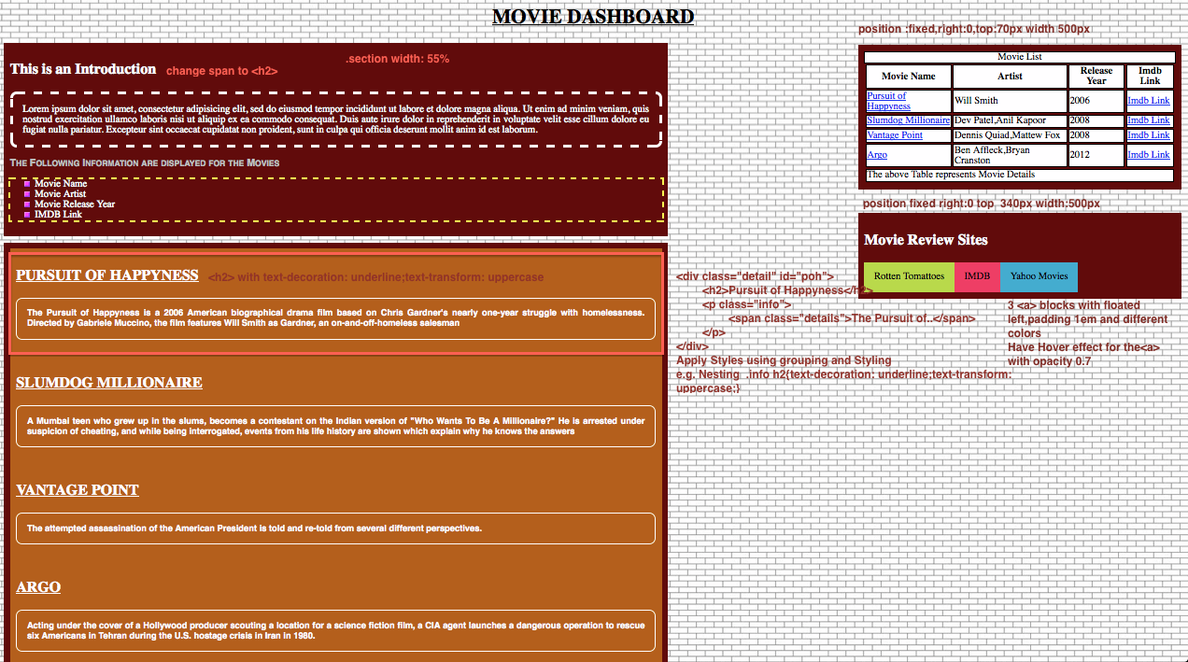

Create a HTML file with the following sections:
- Copy the Content of the “CSSBoxModel.html” into a new HTML File “CSSAdvanced.html”
- Here the Main Section developed in the previous exercise needs to be dimensioned with 55% width.(change it in .section class)
- Have a new Section div for the Movie Description (As Displayed on the Orange color Background)
- Each of the Movie Information div should have a recognizable id.
- Now move the Table to the Right with fixed position as dictated on the Screenshot.
- Similarly Develop a Movie Review Site (Below table section as a new section) and apply the position fixed property. The Contents of the section would be hyperlink to 3 sites as dictated.
- Now when you scroll down, the right side would be fixed at the top and the left section would scroll down.
- On the Table, Add Hyperlink to the Movie Name. This Hyperlink must have the href attribute pointing to the id attribute of the div, which contains information about the movie.
e.g.
in the div which contains the movie details
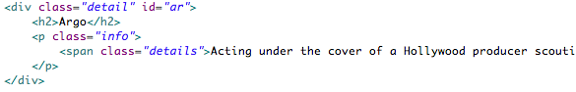
in the Table

<Please provide the list of documents that the trainees need to submit after completing the above exercise(s)>
Hands-On Exercise 5 CSS Image
Estimated Completion Time: xx Minutes
(xx Marks)
Objective: After completing this exercise, you will execute understanding concepts like Grouping, Nesting, Dimension, Offset, Positioning, Floating, Clear ,Align.

Complete the following assignment:

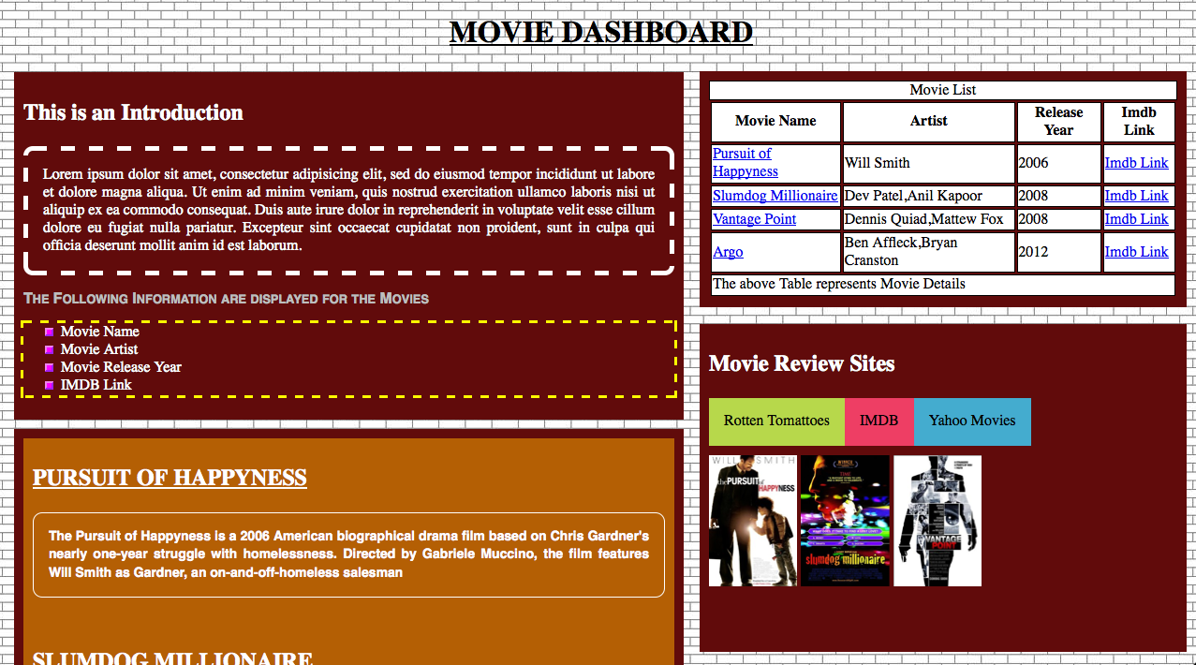

Create a HTML file with the following sections:
- Copy the Content of the “CSSAdvanced.html” into a new HTML File “CSSImage.html”
- In the Movie Review Site include 3 images for the movies. poh.jpg ,slm.jpg,vp.jpg as <img> and apply max-width 33% and max-height:70%
- Wrap these 3 images together with a div.Give width 100% and height 200px for this div.

To Submit: CSSImage.html

